Jason Melnik

10/05/2021

Exam 1

* 1. Mean: 10.42, STDEV: 4.58
  2. The standard deviation represents how far from the average is an accurate representation of the average math grade. This basically represents that if someone scored between 5.84 and 15 it would be considered as a normal score. We learn from this example that most student scored between 5.84 and 15 on their math grade.
  3. As you can see with the graph below most of the grades are within the range of 5 to 15. 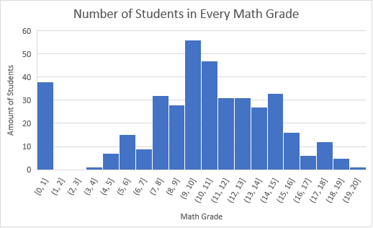
  4. The Z-Score of student two is -0.96. This means that their score is below the average by .96 of a standard deviation.

1. The graph below shows us the study time compared to the math grade that those students received. This graph shows us that you can’t determine math grade from study time because the averages are roughly the same and the standard deviations are closely related. The only thing you can get out of this graph is that if a student spends more than ten hours studying they may end up with a grade 4 and lower unlike the others. 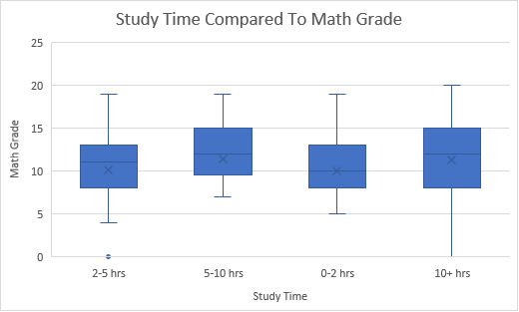
2. From this graph below we can see the percent educated based of each parent. We can see from this graph a clear image of mother and father education status and how many are educated compared to the other educated parents. This graph shows us that there is a large percentage of people that are 4th grade educated and secondary educated.
   1. In the graph below I see that the types of seeds correlate with the asymmetry of the seeds, The lower asymmetry seeds are A type while the higher asymmetry are type C and the middle asymmetry values are type B. This will be extremely helpful in predicting the type of wheat for each seed. Chart, box and whisker chart

      Description automatically generated
   2. The graph below shows us the types in colors that are plotted with their width to legend. The colors that correspond to the type are black is A, red is B, green is C. This graph will be great for predicting since most of type C is in the lower kernel length and width while type B is in the higher kernel length and width. Type A is more in the middle of type C and B with kernel length and width. So, this will be a great use for predicting type since it shows a clear difference between types using the kernel length and width. Chart, scatter chart

      Description automatically generated
3. C50
   1. The below tree would predict the seed to be type ‘A’.Diagram

      Description automatically generated
   2. A B C

A 16 0 3

B 1 26 0

C 6 0 18

* 1. Accuracy: 85.71%

1. Random Forest

A B C

A 19 1 2

B 1 25 0

C 3 0 19

* 1. 90 Percent Accurate.
  2. The Random Forest tree outperformed the C50 tree.